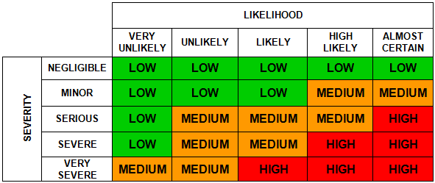

|  |
| --- |
| **Risk Assessment**  **Form** |

|  |  |
| --- | --- |
| **Risk Assessment for Disco** | **Friday 18th October 2024** |

|  |  |  |  |  |  |
| --- | --- | --- | --- | --- | --- |
| **Service** | **All persons involved to sign** | **Team / Section** | **FOSP** | | |
| **Assessment Date** | **October 2024** | **Review Date** | **N/A** | **Reference Number** | **N/A** |

|  |  |  |  |  |  |  |
| --- | --- | --- | --- | --- | --- | --- |
| **What are the hazards**  *(i.e. what can cause harm)* | **Who might be harmed and how?**  *(e.g. employees, pupils, members of the public, etc. and the significant risk(s))?* | **What existing control measures are in place to reduce / prevent the risk?**  *(i.e. what are you already doing?)* | **Considering existing controls, what is the current risk level**  *(i.e. high, medium or low – use the matrix above)* | **Further Action to be taken to control the risk?**  *(i.e. only record action/additional controls measures you are going to implement)* | **Risk level achieved** | **Assigned to** |
| Set up of Disco equipment | Pupils, FOSP members, staff  Injury from equipment falling  Injury to back when carrying | * Only DJ carries the equipment. | M | * Setup should occur before the event begins, and only those responsible permitted to setup and take down equipment. * Manual handling should be used. * First Aider and first aid kit (containing applicable items) available at all times. * Ensure that area is clear of people and only those detailed should be in the area. | L | FOSP helpers, present members of staff and the DJ |
| Trailing cables, slippery or uneven ground, obstacles | Pupils, members of FOSP, staff  Injury due to slips trips and falls | * Head teacher/ caretaker/ carries out regular premises inspections. * FOSP lead carries out checks that area is clear and that any cables are covered. * Barriers in place around disco equipment. | M | * Ensure cables are secure and clearly marked. * Floor condition to be reviewed by FOSP members throughout the event * Drinks not to be allowed into the hall but must be drunk outside the library. * First Aider and first aid kit (containing applicable items) available at all times * Any spillages to be cleared up immediately * Children are supervised at all times by staff and FOSP helpers and not allowed in the area around the disco | L | FOSP helpers, present members of staff and the DJ |
| Electricity | Electric shock / Electrocution | * DJ checks equipment * Caretaker regular checks hall sockets. | M | * All leads visually checked for frays/damage and only used if none found. * Cables secured to floor if trailing. * Only loaded to appropriate level i.e. no additional extender plug sockets to be used (no daisy chaining) | L | FOSP helpers, present members of staff and the DJ |
| Gym equipment in hall | Pupils, members of FOSP, staff  Injury from falling off the equipment |  | M | * Children not allowed to climb on the equipment and reminded by senior member of staff at start. * Children are supervised at all times by staff and FOSP helpers * First Aider and first aid kit (containing applicable items) available at all times | L | FOSP helpers and members of staff supervising the disco |
| Fire | Pupils, members of public, staff  Injury / death | * The school has fire evacuation procedures that need to be followed. | L | * FOSP helpers to be familiar with fire evacuation procedure. * All emergency exits to remain clear. | L | FOSP helpers and members of staff supervising the disco |
| Poor supervision of event and children | Pupils, members of FOSP, staff  Injury, loss of child, abduction, abuse | * Responsibilities for event supervision to be established between school and event organisers * Asked that children must not be left unattended until they have been checked in. * Safeguarding policies of school shared with event organisers. | M | * Only DBS checked FOSP members or member of staff to be alone with a child that isn’t theirs. * The children come in and exit through the double hall doors in the front playground. The hall doors are supervised at all times to ensure no one leaves. * Children are ticked off the attendee lists in their year groups as they enter so we know which children are attending. * One FOSP member is responsible for each year group. They will ensure children are checked in and picked up by the correct adult. If they are unsure they ask for help from other FOSP members / staff. * All children attending must have a permission slip from their parents with a contact number and details of who is picking them up. * Children are supervised at all times by staff and FOSP helpers. * No running around or playing tag or chase or doing gymnastics in the hall. The senior member of staff from school reminds children of the expectations. * Adults only allowed into the disco if they are volunteering and we have their names listed prior to the event. * Children use only Reception toilet areas and are supervised in the corridors. | L | FOSP helpers and members of staff supervising the disco |
| Overcrowding of venue | Pupils, members of FOSP, staff  Injury, heat exhaustion | * Venue capacity known and not exceeded | M | * Children to bring in named water bottle and leave outside the library * Clear ventilation – windows opened. | L | FOSP helpers and members of staff supervising the disco |
| High room temperature | Pupils, members of FOSP, staff  Heat exhaustion  Dehydration |  | M | * Children to bring in named water bottle and leave outside the library. * Children suffering from being too hot encouraged to have a rest and a drink * Windows open – double doors open to allow ventilation | L | FOSP helpers and members of staff supervising the disco |
| Glow sticks | Pupils, members of FOSP, staff  Irritation / illness as a result of ingestion of or exposure to liquid inside | * Ensure use of non-toxic glow sticks. * Ensure glow sticks aren’t damaged | M | * Staff and FOSP helpers to supervise use of glow sticks to ensure children don’t put them in their mouths / bite into them * First aider on hand if children do ingest liquid or it comes into contact with the skin. | L | FOSP helpers and members of staff supervising the disco |
| Sweets | Pupils  Choking, allergic reaction | * Sweets to be given to children on exit under the supervision of their parents or carers | L | * First Aider and first aid kit (containing applicable items) available. | L | FOSP helpers and members of staff supervising the disco |
| Halloween gift bags | Pupils  Choking, injury | * Gift bags to be given to children on exit under the supervision of their parents or carers | L | * First Aider and first aid kit (containing applicable items) available. | L | FOSP helpers and members of staff supervising the disco |

|  |  |  |  |
| --- | --- | --- | --- |
| **Name of Assessor** | Jonathan West | **Signature** | Jonathan West |

|  |  |  |  |
| --- | --- | --- | --- |
| **Name of Manager responsible for activity / process** | Amy Williams | **Signature** | Amy Williams |

|  |
| --- |
| **Risk Assessment Review Log** |

Only use this log to confirm that there have been no changes to the current assessment; otherwise an updated risk assessment must be done

|  |  |  |  |
| --- | --- | --- | --- |
| Initial Review Date | 31st January 2024 | | |
| Assessor’s Signature | E Heron | Date: | 31st January 2024 |
| Signature of Responsible Manager |  | Date: |  |

|  |  |  |  |
| --- | --- | --- | --- |
| Next Review Date | 12 months from initial review | | |
| Assessor’s Signature |  | Date: |  |
| Signature of Responsible Manager |  | Date: |  |

|  |  |  |  |
| --- | --- | --- | --- |
| Initial Review Date | 24 months from initial review | | |
| Assessor’s Signature |  | Date: |  |
| Signature of Responsible Manager |  | Date: |  |

|  |  |  |  |
| --- | --- | --- | --- |
| Initial Review Date | 36 months from initial review | | |
| Assessor’s Signature |  | Date: |  |
| Signature of Responsible Manager |  | Date: |  |

|  |  |  |  |
| --- | --- | --- | --- |
| Initial Review Date | 48 months from initial review | | |
| Assessor’s Signature |  | Date: |  |
| Signature of Responsible Manager |  | Date: |  |

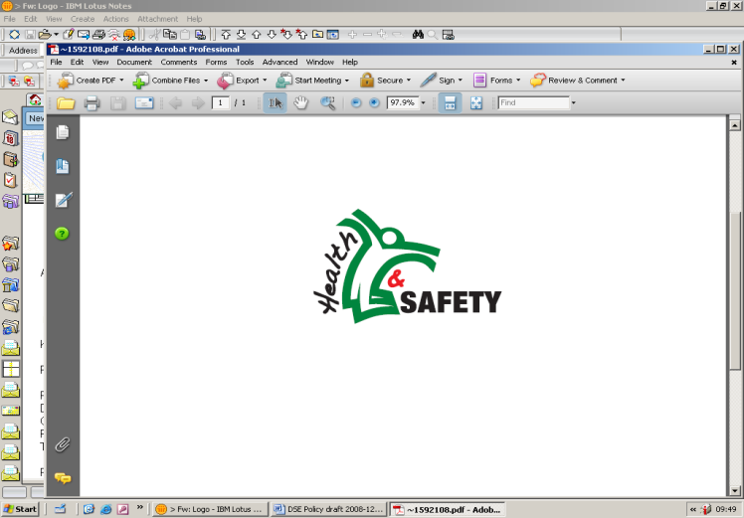

|  |  |
| --- | --- |
| **Risk Assessment(s) for (Activity/Process/Operation)** | **School Disco** |

*This form can be used to record and demonstrate that the above risk assessment(s) has been provided to relevant employees (as below) to inform them of the risk assessment findings (i.e. the hazards, risks, and control measures associated with their work).*

|  |  |  |
| --- | --- | --- |
| **Name of Persons involved in the Activity/ Process/ Operation** | **Signature** | **Date** |
|  |  |  |
|  |  |  |
|  |  |  |
|  |  |  |
|  |  |  |
|  |  |  |
|  |  |  |
|  |  |  |
|  |  |  |
|  |  |  |
|  |  |  |
|  |  |  |
|  |  |  |
|  |  |  |
|  |  |  |
|  |  |  |
|  |  |  |
|  |  |  |