Year 1 TIMETABLE

 | Registration  Morning activity | 1st Lesson |  | Break |  | 2nd Lesson | Lunch |  | 3rd Lesson |  | 4th Lesson |  | School Day End 3.20pm
Time | 8.45-8.55 | 9:05-10:30 |  | 10:30-10:50 | 10:50-11:10 | 11:10-12 | 12-1 | 1pm-1:15 | 1:15-2 |  | 2-3 |  | 3.00 – 3:20
M | Daily Starter | Assembly 9:05-9:30 | 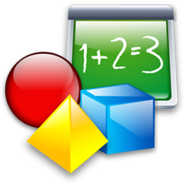  Maths | Break  Healthy snack brought in.  Sweets/chocolate NOT permitted in school |  | English   | Lunch  Children may bring own packed lunch or purchase school meal-Sweets NOT permitted in school | Register-Master number |   PE |  | Time in Provision-computing   |  | Class Story
T | Daily Starter | Maths |  | Break  Healthy snack brought in.  Sweets/chocolate NOT permitted in school |  | English | Lunch  Children may bring own packed lunch or purchase school meal-Sweets NOT permitted in school | Register-Master number |   Outdoor Learning – Science |  |  |  | Class Assembly
W | Daily Starter | Maths |  | Break  Healthy snack brought in.  Sweets/chocolate NOT permitted in school |  | English | Lunch  Children may bring own packed lunch or purchase school meal-Sweets NOT permitted in school | Register-master number | Humanities - Topic   |  |  | RE    Library | 2:55-3:15Singing
T | Daily Starter | Maths |  | Break  Healthy snack brought in.  Sweets/chocolate NOT permitted in school |  | English | Lunch  Children may bring own packed lunch or purchase school meal-Sweets NOT permitted in school | Register | PSHE |  |  | Time in provision | 2:55-3:15 Whole School Story
F | Daily Starter | Assembly 9:05-9:30 | Maths | Break  Healthy snack brought in.  Sweets/chocolate NOT permitted in school |  | English | Lunch  Children may bring own packed lunch or purchase school meal-Sweets NOT permitted in school | Register-master number | Music  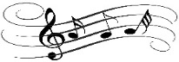 | Time in Provision-Art |  |  | Class Story

