YEAR 6 TIMETABLE Autumn 1
 | Registration | Reading/ Assembly |  | Lesson 1 | Break | SPAG | Lesson 2 | Lunch | Afternoon Session | Afternoon Session |  |  | School Day end 3.25pm
 | 8.45-9.00 | 9.00 - 9.30 |  | 9.30-10.30 | 10.30 – 10.50 | 10.50 – 11.10 | 11.10 – 12.00 | 12.00 – 1.00 | 1.00 – 2.00 | 2.00 – 2.55 |  |  | 2.55-3.20
M | Fluent in Five  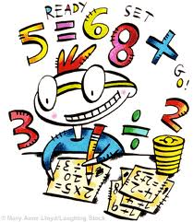 | WHOLE SCHOOL ASSEMBLY |  | 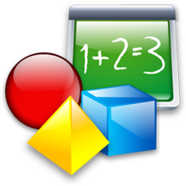  Maths | Break  Healthy snack brought in.  Sweets/chocolate NOT permitted in school | Spelling   |   English | Lunch  Children may bring own packed lunch or purchase school meal  Sweets NOT permitted in school | Computing   |   Geography/History |  |  |   DEAR
T | Fluent in Five |   Whole  Class  Reading |  | Maths | Break  Healthy snack brought in.  Sweets/chocolate NOT permitted in school |   SPAG | English | Lunch  Children may bring own packed lunch or purchase school meal  Sweets NOT permitted in school |   Art/DT | Music   |  | In the News Assembly | DEAR
W | Fluent in Five | Whole  Class  Reading |  | Maths (Mrs Fade) | Break  Healthy snack brought in.  Sweets/chocolate NOT permitted in school | Spelling | English (Mrs Fade) | Lunch  Children may bring own packed lunch or purchase school meal  Sweets NOT permitted in school | PE (Mrs Fade)   |   RE/PSHE (Mrs Fade) |  |  | Singing Assembly
T | Fluent in Five |  | Whole  Class  Reading | Maths | Break  Healthy snack brought in.  Sweets/chocolate NOT permitted in school | SPAG | English | Lunch  Children may bring own packed lunch or purchase school meal  Sweets NOT permitted in school |   Science (laptops 1-2) |  |   MFL (French) |  | Whole School Reading Assembly
F | Fluent in Five | Whole School Assembly |  | Maths | Break  Healthy snack brought in.  Sweets/chocolate NOT permitted in school | Spelling | English | Lunch  Children may bring own packed lunch or purchase school meal  Sweets NOT permitted in school | Extra Theme Session – Science, Geography, History, Art/DT | PE |  |  | DEAR

