YEAR 4 TIMETABLE Autumn 1
 | Registration | Reading/ Assembly |  | Lesson 1 | Break | SPAG | Lesson 2 | Lunch | Afternoon Session | Afternoon Session |  | School Day end 3.25pm
 | 8.45-9.05 | 9.05 - 9.30 |  | 9.30-10.30 | 10.30 – 10.50 | 10.50 – 11.10 | 11.10 – 12.00 | 12.00 – 1.00 | 1.00 – 2.00 | 2.00 – 2.55 |  | 2.55-3.20
M | Fluent in Five  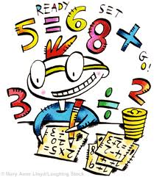 | WHOLE SCHOOL ASSEMBLY |  | 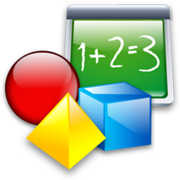  Maths | Break  Healthy snack brought in.  Sweets/chocolate NOT permitted in school | Spelling   |   English | Lunch  Children may bring own packed lunch or purchase school meal  Sweets NOT permitted in school |   Art/DT |   Geography/History |  |   DEAR
T | Fluent in Five | TTRS |  | Maths | Break  Healthy snack brought in.  Sweets/chocolate NOT permitted in school | 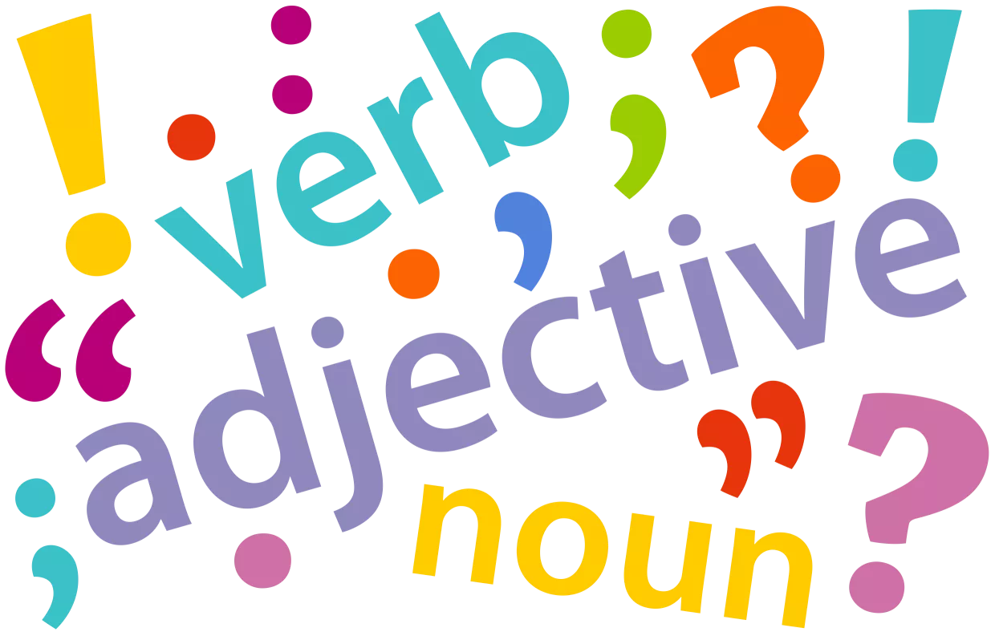  SPAG | English | Lunch  Children may bring own packed lunch or purchase school meal  Sweets NOT permitted in school |   PE |  |  | Class Assembly
W | Fluent in Five | TTRS |  | Maths | Break  Healthy snack brought in.  Sweets/chocolate NOT permitted in school | Spelling | English | Lunch  Children may bring own packed lunch or purchase school meal  Sweets NOT permitted in school |   Science |  | DEAR | Whole School Singing Assembly
T | Fluent in Five |  | TTRS | Maths | Break  Healthy snack brought in.  Sweets/chocolate NOT permitted in school | SPAG | English | Lunch  Children may bring own packed lunch or purchase school meal  Sweets NOT permitted in school |   RE/PSHE | PE |  | Whole School Reading Assembly
F | Fluent in Five | Whole School Assembly |  | Maths | Break  Healthy snack brought in.  Sweets/chocolate NOT permitted in school | Spelling | English | Lunch  Children may bring own packed lunch or purchase school meal  Sweets NOT permitted in school | Computing   | Music   |  | DEAR

