What can you find out about these famous Polish heritage people?

[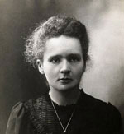](https://www.google.co.uk/url?sa=i&rct=j&q=&esrc=s&source=images&cd=&ved=2ahUKEwi-3vG06-DfAhWCr3EKHSeGD7oQjRx6BAgBEAU&url=https://www.biographyonline.net/people/famous/polish-people.html&psig=AOvVaw1ICR1vyCYF-yucVuLqpXV_&ust=1547128086032864)

Marie Curie

[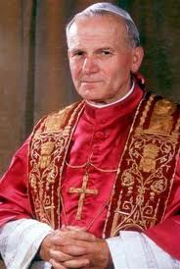](https://www.google.co.uk/url?sa=i&rct=j&q=&esrc=s&source=images&cd=&cad=rja&uact=8&ved=2ahUKEwjM04n-nuHfAhUyoXEKHciZDAIQjRx6BAgBEAU&url=https://polishgreatness.blogspot.com/2012/07/famous-polish-quotations.html&psig=AOvVaw1ICR1vyCYF-yucVuLqpXV_&ust=1547128086032864)

Pope Jean Paul 11

[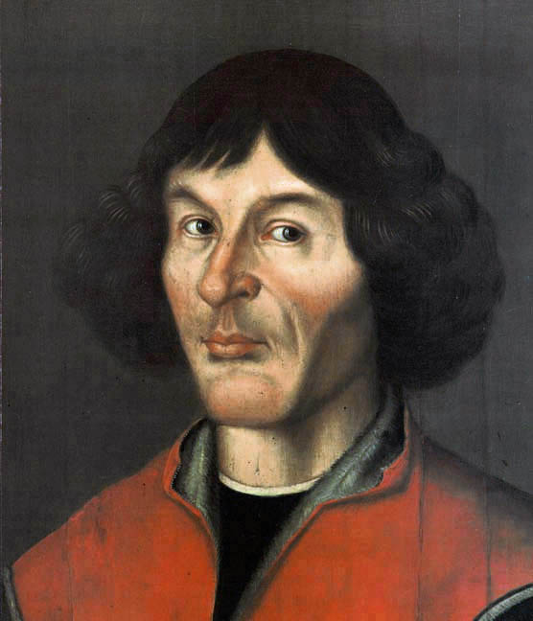](https://www.google.co.uk/url?sa=i&rct=j&q=&esrc=s&source=images&cd=&cad=rja&uact=8&ved=2ahUKEwjIu7qToOHfAhVeUxUIHSEpAdYQjRx6BAgBEAU&url=https://crazypolishguy.com/2015/02/13/five-poles-who-changed-the-world/&psig=AOvVaw1ICR1vyCYF-yucVuLqpXV_&ust=1547128086032864)

Nicholaus Copernicus

[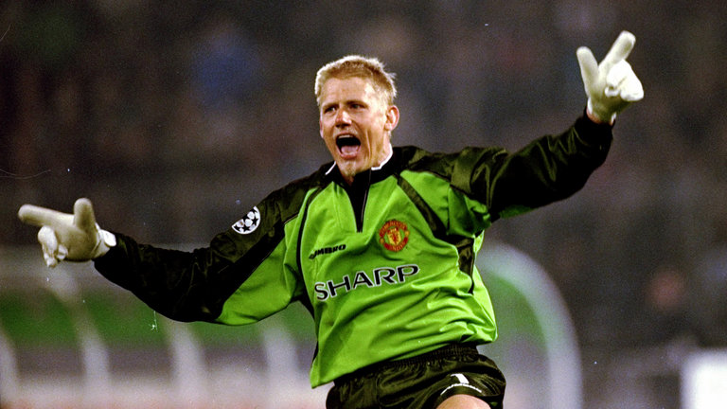](https://www.google.co.uk/url?sa=i&rct=j&q=&esrc=s&source=images&cd=&cad=rja&uact=8&ved=2ahUKEwjzg__RouHfAhXztHEKHdE0AcoQjRx6BAgBEAU&url=https://www.skysports.com/football/news/11667/10748053/peter-schmeichel-impressed-by-manchester-united-progress-under-jose-mourinho&psig=AOvVaw0wsDyNpNxLCbD6ISwhzQYl&ust=1547142832944320)

Peter Boleslaw Schmeichel

[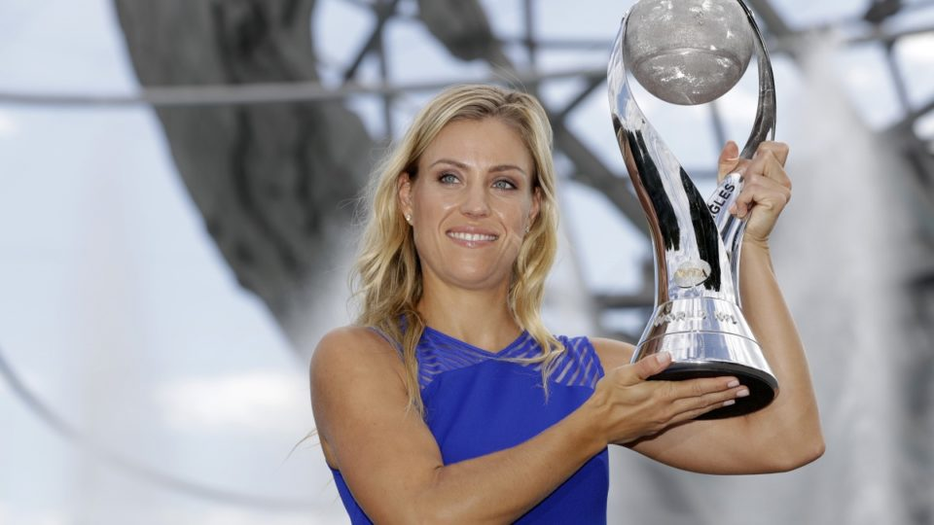](https://www.google.co.uk/url?sa=i&rct=j&q=&esrc=s&source=images&cd=&cad=rja&uact=8&ved=2ahUKEwiR9o70o-HfAhX9ThUIHUwDBQYQjRx6BAgBEAU&url=https://thenewdaily.com.au/sport/tennis/2016/09/12/kerber-replaces-williams-number-one/&psig=AOvVaw1PHyTBDKOHiTnYisQgqGbW&ust=1547143217140309)

Angelique kerber

[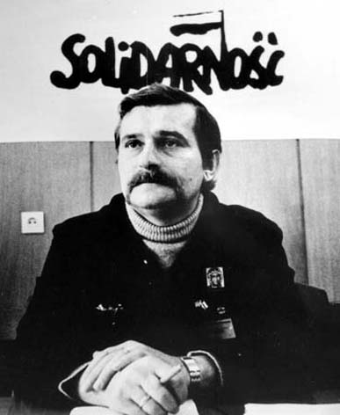](http://www.google.co.uk/url?sa=i&rct=j&q=&esrc=s&source=images&cd=&cad=rja&uact=8&ved=2ahUKEwiEzqf1pOHfAhUVVBUIHQ8vAhcQjRx6BAgBEAU&url=http://monipag.com/florian-bauer/2017/06/05/lech-walesa/&psig=AOvVaw0yifxg2RCwAKMyvc9lsOOy&ust=1547143486330438)

Lech Walesa

[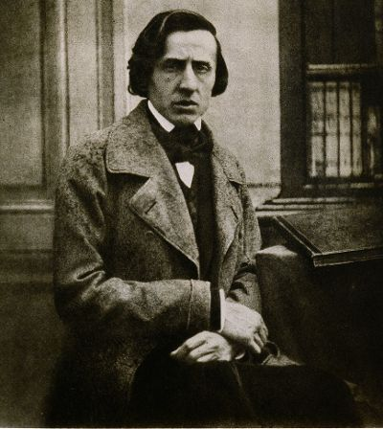](https://www.google.co.uk/url?sa=i&rct=j&q=&esrc=s&source=images&cd=&cad=rja&uact=8&ved=2ahUKEwjB5Pi4peHfAhXfRBUIHYEdCQkQjRx6BAgBEAU&url=https://www.allmusic.com/artist/fr%C3%A9d%C3%A9ric-chopin-mn0000066824&psig=AOvVaw1dZlwPTSsjGbIifb9mtqKi&ust=1547143643275068)

Frederick Chopin

[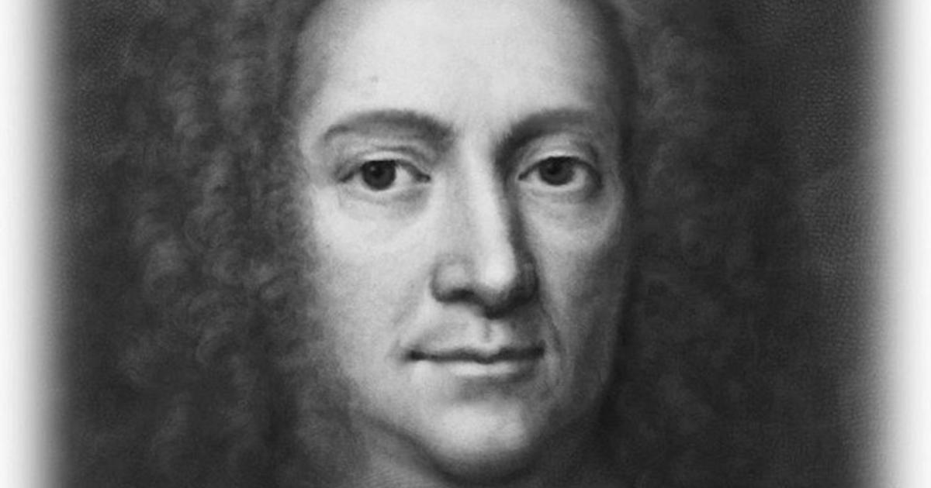](https://www.google.co.uk/url?sa=i&rct=j&q=&esrc=s&source=images&cd=&cad=rja&uact=8&ved=2ahUKEwjf8sKvpuHfAhVaURUIHdSxBTcQjRx6BAgBEAU&url=https://www.cbsnews.com/news/almanac-daniel-fahrenheit/&psig=AOvVaw2Ar2jHfXIWFqPoN_2Uv01T&ust=1547143860210309)

Daniel Farenheit

[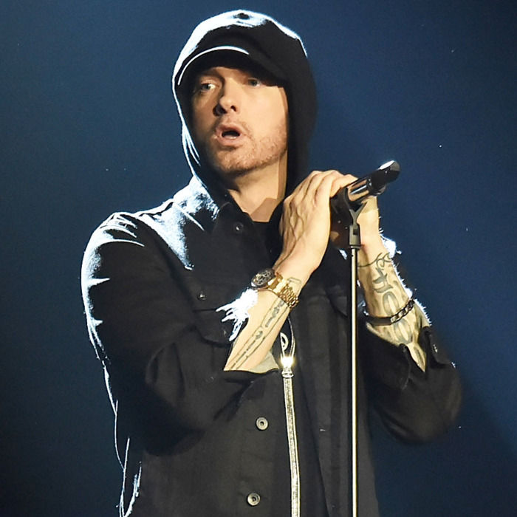](https://www.google.co.uk/url?sa=i&rct=j&q=&esrc=s&source=images&cd=&cad=rja&uact=8&ved=2ahUKEwiYsYKUp-HfAhXioXEKHZ0hCeUQjRx6BAgBEAU&url=https://www.vulture.com/2018/09/review-eminem-kamikaze-album.html&psig=AOvVaw2YRieYeAOmiRLbzHYNb8AU&ust=1547144106141448)

Eminem

[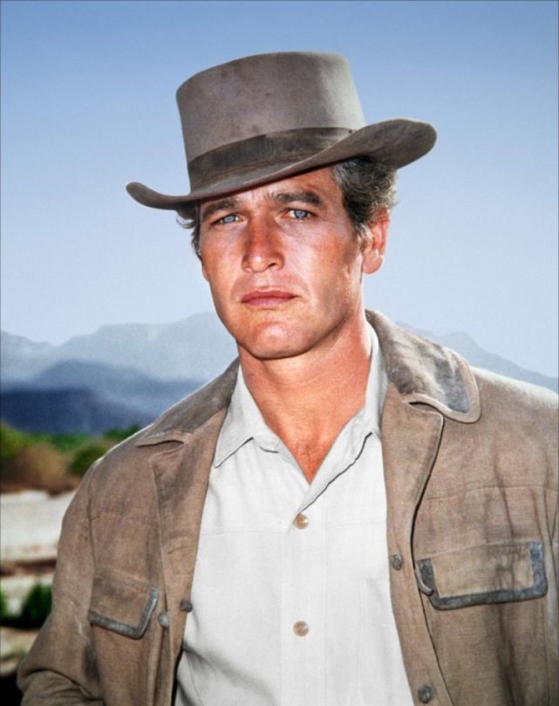](https://www.google.co.uk/url?sa=i&rct=j&q=&esrc=s&source=images&cd=&cad=rja&uact=8&ved=2ahUKEwjWpaH1seHfAhXuUBUIHSSqApkQjRx6BAgBEAU&url=https://www.imdb.com/title/tt0064115/mediaviewer/rm2190795776&psig=AOvVaw1L7YPq3ZomHu5nQq4JLAol&ust=1547147016425348)

Paul Newman

[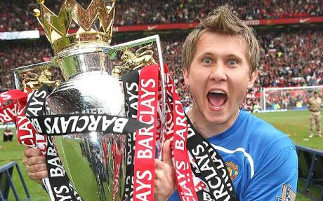](http://www.google.co.uk/url?sa=i&rct=j&q=&esrc=s&source=images&cd=&cad=rja&uact=8&ved=2ahUKEwjr7vLxq-HfAhW7WxUIHcYBDUYQjRx6BAgBEAU&url=http://www.fitbathatba.com/2011/11/tomasz-kuszczak-im-slave.html&psig=AOvVaw3DbeLXVTwGUohN-ksCL_YN&ust=1547145356289994)

Tomasz kuszczak

[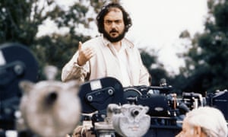](https://www.google.co.uk/url?sa=i&rct=j&q=&esrc=s&source=images&cd=&ved=2ahUKEwimjI7hsOHfAhVfQxUIHfC-AeMQjRx6BAgBEAU&url=https://www.theguardian.com/film/2018/jul/15/stanley-kubrick-lost-screenplay-burning-secret-found&psig=AOvVaw3DLg8CyasXXMpNdpbdtO93&ust=1547146679464929)

Stanley Kubrick

[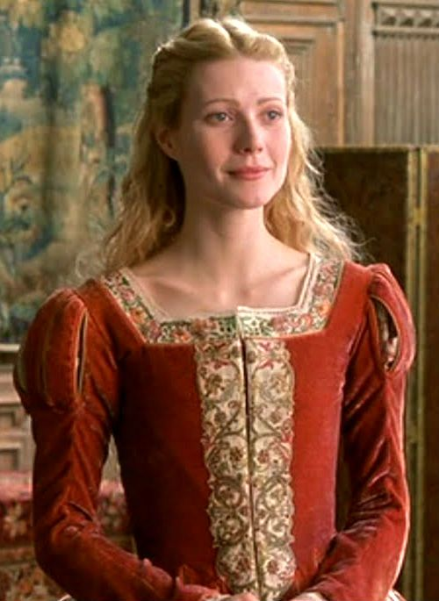](https://www.google.co.uk/url?sa=i&rct=j&q=&esrc=s&source=images&cd=&cad=rja&uact=8&ved=2ahUKEwjinsynq-HfAhXdTBUIHRL_BggQjRx6BAgBEAU&url=https://www.pinterest.com/pin/495958977684670952/&psig=AOvVaw2vpdQG3EGsvq6YGqWO7XAh&ust=1547145189619924)

Gwyneth Paltrow

[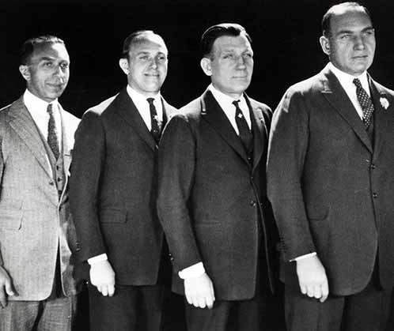](https://www.google.co.uk/url?sa=i&rct=j&q=&esrc=s&source=images&cd=&cad=rja&uact=8&ved=2ahUKEwjs3dvJrOHfAhVBonEKHU6zA8IQjRx6BAgBEAU&url=https://brightlightsfilm.com/the-fall-of-the-house-of-warner-the-warner-brothers/&psig=AOvVaw3s9r1NsoAN2RvN-1S-EoBQ&ust=1547145571741997)

The Warner Brothers

I[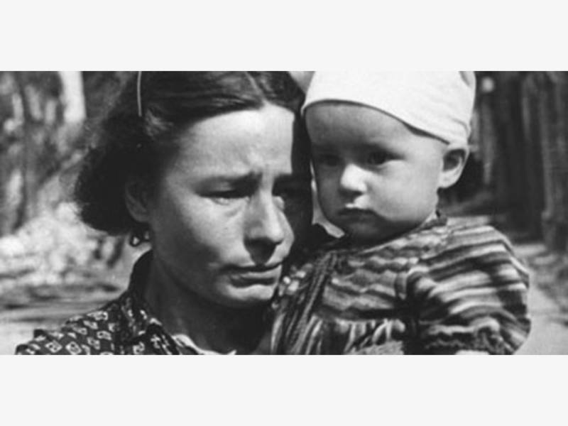](https://patch.com/california/berkeley/irena-sendler-rescuing-rescuer-freight-salvage-sat-10-7)

Irena Sendler

[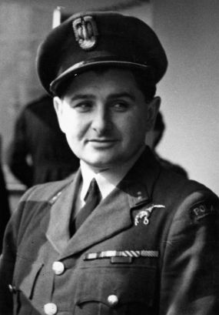](https://www.google.co.uk/url?sa=i&rct=j&q=&esrc=s&source=images&cd=&cad=rja&uact=8&ved=2ahUKEwjjgZunruHfAhUyRxUIHS0JCwMQjRx6BAgBEAU&url=https://www.pinterest.com/pin/535013630725095169/&psig=AOvVaw3hz6_gPG1DxKe3LNtR3O6C&ust=1547146035545328) 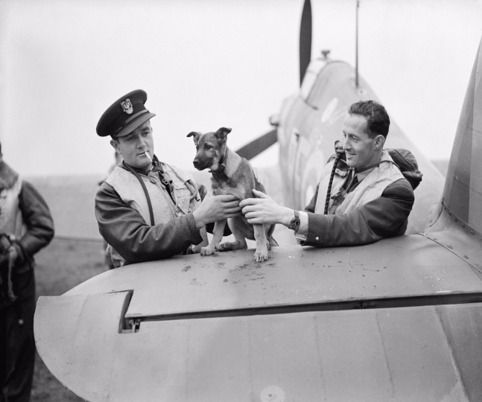

Tony Glowacki Jan Zumbach and Miroslaw Feric

and puppy mascot

[](https://www.google.co.uk/url?sa=i&rct=j&q=&esrc=s&source=images&cd=&cad=rja&uact=8&ved=2ahUKEwitoe2Z6-LfAhVI6RoKHfwcClAQjRx6BAgBEAU&url=https://www.mirror.co.uk/3am/celebrity-news/ola-jordan-blasts-current-dancers-9059164&psig=AOvVaw1O5rW5XoFfTGb1UmvNog21&ust=1547196602239663)

Ola Jordan

[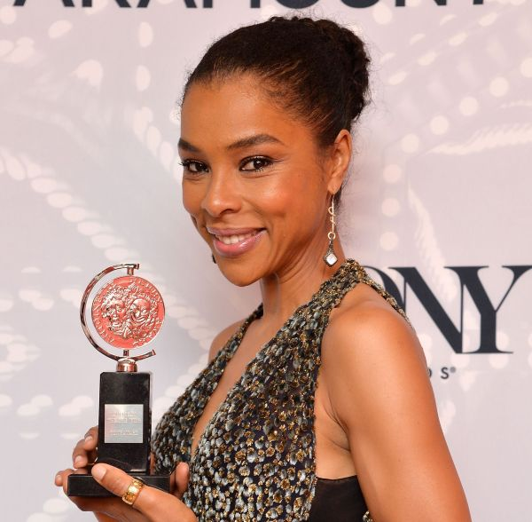](https://www.google.co.uk/url?sa=i&rct=j&q=&esrc=s&source=images&cd=&cad=rja&uact=8&ved=2ahUKEwiC4PeCj-PfAhVyyoUKHSKsAIQQjRx6BAgBEAU&url=https://jewishbusinessnews.com/2014/06/10/sophie-okonedo-wins-tony-for-best-performance-by-an-actress-in-a-play/&psig=AOvVaw2RSC8B0Qnao1ni4b_AvuOz&ust=1547206307126165)

Sophie Okenodo

[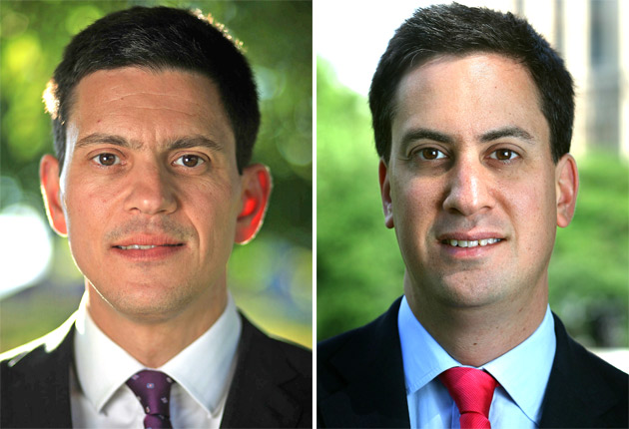](https://www.google.co.uk/url?sa=i&rct=j&q=&esrc=s&source=images&cd=&cad=rja&uact=8&ved=2ahUKEwiPr_HlkuPfAhWKxYUKHcWxCo0QjRx6BAgBEAU&url=https://www.independent.co.uk/news/uk/politics/david-miliband-twice-as-popular-as-ed-says-poll-2079484.html&psig=AOvVaw3oKVl8bx1ANJ2tv5FSAX-_&ust=1547207293807262)

David and Ed Miliband