YEAR 3 TIMETABLE Autumn 1
 | Registration | Reading/ Assembly |  | Lesson 1 | Break | SPAG | Lesson 2 | Lunch | Afternoon Session | Afternoon Session |  | School Day end 3.25pm
 | 8.45-9.05 | 9.05 - 9.30 |  | 9.30-10.30 | 10.30 – 10.50 | 10.50 – 11.10 | 11.10 – 12.00 | 12.00 – 1.00 | 1.00 – 2.00 | 2.00 – 2.55 |  | 2.55-3.20
M | Fluent in Five  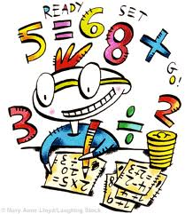 | WHOLE SCHOOL ASSEMBLY |  |   English | Break  Healthy snack brought in.  Sweets/chocolate NOT permitted in school | SPAG   | 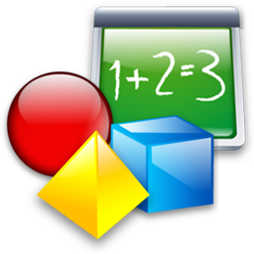  Maths | Lunch  Children may bring own packed lunch or purchase school meal  Sweets NOT permitted in school |   Music/Ukelele |   PE |  |   DEAR
T | Fluent in Five | Spelling |  | English | Break  Healthy snack brought in.  Sweets/chocolate NOT permitted in school | TTRS   | Maths | Lunch  Children may bring own packed lunch or purchase school meal  Sweets NOT permitted in school |   Computing |   Art/DT |  | Class Assembly
W | Fluent in Five | Spelling |  | English | Break  Healthy snack brought in.  Sweets/chocolate NOT permitted in school | TTRS | Maths | Lunch  Children may bring own packed lunch or purchase school meal  Sweets NOT permitted in school |   Science |  | RE   | Whole School Singing Assembly
T | Fluent in Five |  | Spelling | English | Break  Healthy snack brought in.  Sweets/chocolate NOT permitted in school | TTRS | Maths | Lunch  Children may bring own packed lunch or purchase school meal  Sweets NOT permitted in school |   Geography/History |  |  | Whole School Reading Assembly
F | Fluent in Five | Whole School Assembly |  | English | Break  Healthy snack brought in.  Sweets/chocolate NOT permitted in school | SPAG | Maths | Lunch  Children may bring own packed lunch or purchase school meal  Sweets NOT permitted in school | PE | French/PSHE     |  | DEAR

