YEAR 2 TIMETABLE Autumn 1
 | Registration | Reading/ Assembly |  | Lesson 1 | Break | SPAG | Lesson 2 | Lunch | Afternoon Session |  | Afternoon Session |  | School Day end 3.20pm
 | 8.45-9.05 | 9.05 - 9.30 |  | 9.30-10.30 | 10.30 – 10.50 | 10.50 – 11.10 | 11.10 – 12.00 | 12.00 – 1.00 | 1.00 – 2.00 |  | 2.00 – 2.55 |  | 2.55-3.20
M | Spelling/handwriting | WHOLE SCHOOL ASSEMBLY |  | 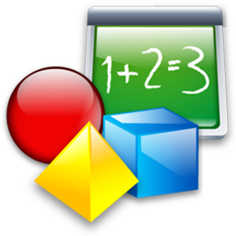Maths | Break  Healthy snack brought in.  Sweets/chocolate NOT permitted in school | Phonics   | English | Lunch  Children may bring own packed lunch or purchase school meal  Sweets NOT permitted in school | Art/DT |  | PSHE | Mastering number  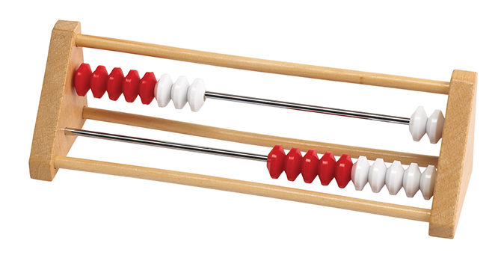 | DEAR
T | Spelling/handwriting | Phonics |  | Maths | Break  Healthy snack brought in.  Sweets/chocolate NOT permitted in school | Mastering number | English | Lunch  Children may bring own packed lunch or purchase school meal  Sweets NOT permitted in school | RE |  | Computing   |  | DEAR
W | Spelling/handwriting | Phonics |  | Maths | Break  Healthy snack brought in.  Sweets/chocolate NOT permitted in school | Mastering number | English | Lunch  Children may bring own packed lunch or purchase school meal  Sweets NOT permitted in school | Science   |  | French | Mastering number | Whole School Singing Assembly
T | Spelling/handwriting |  | Phonics | Maths | Break  Healthy snack brought in.  Sweets/chocolate NOT permitted in school | Mastering number | English | Lunch  Children may bring own packed lunch or purchase school meal  Sweets NOT permitted in school | PE |  | Computing |  | Whole School Reading Assembly
F | Spelling/handwriting | Whole School Assembly |  | Maths | Break  Healthy snack brought in.  Sweets/chocolate NOT permitted in school | Phonics | English | Lunch  Children may bring own packed lunch or purchase school meal  Sweets NOT permitted in school | Geography/History   | 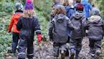 Forest School |  |  | Music  

